PLEASE ENTER RESPONSES IN APPROPRIATE AREA ON THIS SEAT. NOT ON A SEPARATE DOCUMENT.

Lab 5 Animals I: Invertebrates

Today’s lab will feature a series of excellent videos, mostly from the Shape of Life series (http://shapeoflife.org/ ). We will explore a range of invertebrate phyla, study their unique evolutionary adaptations and unique life history traits.
- Make sure you have an internet connection to complete this lab.

Porifera
Poriferans are sponges; an early branching event in the history of animals separated them from other animals. Fossil sponges are among the oldest known animal fossils, dating from the Late Precambrian. Unlike other animals, they lack true tissues and organs, and have no body symmetry. All sponges are sessile aquatic animals. Although there are freshwater species, the great majority are marine (salt water) species, ranging from tidal zones to depths exceeding 8,800 m (5.5 mi). The shapes of their bodies are adapted for maximal efficiency of water flow through the central cavity, where it deposits nutrients, and leaves through a hole called the osculum. The flow of water through the sponge is unidirectional, driven by the beating of flagella which line the surface of chambers connected by a series of canals.
Sponges have no nervous systems. The mesohyl functions as an endoskeleton in most sponges, and is the only skeleton in soft sponges that encrust hard surfaces such as rocks. More commonly, the mesohyl is stiffened by spicules of calcium carbonate or silica, by spongin fibers or both.
Most species use sexual reproduction, releasing sperm cells into the water to fertilize ova that in some species are released and in others are retained by the "mother". The fertilized eggs form larvae which swim off in search of places to settle. Sponges are known for regenerating from fragments that are broken off, although this only works if the fragments include the right types of cells. A few species reproduce asexually by budding. When conditions deteriorate, for example as temperatures drop, many freshwater species and a few marine ones produce gemmules, "survival pods" of unspecialized cells that remain dormant until conditions improve and then either form completely new sponges or recolonize the skeletons of their parents.
Watch this cool documentary on sponges http://www.shapeoflife.org/video/sponges-origins and use it and the reading above to answer the following questions.
- How many species of sponge have been identified scientifically?
There are 900 species
- What types of habitats do they occur in?
The sponges occur both in saltwater and freshwater habitants

- How does a sponge “resurrect” itself?
The sponges “resurrect” itself after the cells that had been previously separated are capable of recognizing each other, thus coming together to form new ones.
- What important trait do sponges share with other animals? What is a bath sponge actually?
The Important trait that is shared by the sponges and other animals is that their cells are shared together by the protein collagen. The bath sponges comprise of skeleton of collagen.
- What are spicules?
Spicules are tiny structures that functions as sponges’ fingerprint, as well as giving them their form.
- What type of reproduction do sponges have and how do they reproduce?
Sponges reproduces through sexual reproduction, where sperm fertilizes an egg.
Use section 33.1 and figure 33.4 in your textbook to answer the following questions and fill in the animal table. (Figures 33.1 & 33.4 were sent to you as a separate attachment.)
- Examine the piece of Scypha sponge. Identify the spogocoel - Is this a coelom?

Spogocoel is a cavity where the water passes through and is a coelom.
- How do sponges feed?

They are filter feeders, where they take in food particles as they filter them out of the surrounding environment.
- What stages of the sponge life cycle are sessile and labile?
Sessile and labile are stages of the sponge’s lifecycle in which the zygote turns to labile larvae, before swimming to look for an adequate substance so as to become sessile.

- What other marine organisms did we study that had silica in their bodies?
Diatoms

Cnidaria
One of the oldest living lineages of animals is the Cnidaria which include hydras, jellies, and corals. Their relatively simple radially symmetric body plan with a basic gastrovascular cavity is nearly unchanged from their 560 million year old ancestors. Their body plan is essentially a sac with a central digestive compartment, the gastrovascular cavity with a single opening that serves as both mouth and anus. When the mouth is closed and water is held under pressure, the cavity functions as a hydrostatic skeleton allowing the animal to contract certain cells and change shape.
There are two forms of body plan
- The cylindrical and sessile polyp, which primarily remains attached to a substrate while extending tentacles for feeding

- The dome-like and motile medusa which can swim freely.
Cnidarian species may exist in only one form or have both forms as stages in their life cycle.
Watch this video about Cnidarians. http://shapeoflife.org/video/cnidarians-life-move
- What evolutionary “inventions” were cnidarians the first animals on Earth to have?
The muscles and nerves that causes behavior as well as the stomach and mouth for digestion were the first Evolutionary inventions that cnidarians were the first animals on earth to have.

- What are nematocysts and what are they used for?
They are specialized capsules that are located along anemone’s tentacles. Nematocysts are used as weapon of piercing targets and paralyzing them with toxins.

- What body plan do coral have?
Polyp body plan
- What is unique about the anemone Stomphia?
Anemone stamphia are unique in that they can swim away from predators by contracting their whole body.
- Describe the traits that changed in the evolution of jellyfish from anemone ancestors.
The traits that changed during the evolution of jellyfish from the anemone ancestor are the extensions of the edges of their mouths and the arm-like feeding structures.
- Describe the body plan of the jellyfish Praya.
Their body plan comprises of different shapes and sizes with cylindrical polyps and motile Medusa.

Coral bleaching
Watch this excellent video on coral bleaching. http://www.hhmi.org/biointeractive/coral-bleaching
- What is the genetic composition of a coral colony?
It is sequence of identical-tiny polyps

- What gives a coral polyp its color?
Zooxanthellae

- What cell layers does a coral polyp have and where are the symbionts located?
Coral polyp has Gastrodermis and Epidermis cells layers and its symbionts are located in the Gastrodermis.
- What type of organism is involved in a mutualistic symbiosis with the coral?
Dinoflagellate Zooxanthellae
- Describe the process of coral bleaching
Coral breaching is when a colony spits out symbionts and the coral turns from tan to white.
- How much of the coral’s energy is produced by the symbiont?
75%-80% of the coral’s energy is generated by symbiont.

Platyhelminthes
This phylum consists of flatworms which live in marine, freshwater, and moist terrestrial habitats. They include free-living as well as parasitic species such as tapeworms. They earn their name from their dorsoventrally flattened body shape. Flatworms can range in size from <1mm planarians to tapeworms more than 20m (65ft) long!
Platyhelminthes are acoelomates (lacking a body cavity), but their flattened shape puts all of their cells close to water aiding in diffusion and gas exchange.
Tapeworms are segmented flatworms that live most of their life cycle within the guts of animals, although they must exist temporarily in the outside environment as eggs in order to transfer between and infect new hosts. There are six species that infect humans, one of the most common of which is Taenia solium the pork tapeworm. Watch this short video from the highly sensationalist program Monsters Inside Me from Animal Planet. http://www.animalplanet.com/tv-shows/monsters-inside-me/videos/meter-long-tapeworm/
- How many people are infected with pork tapeworm worldwide? What percentage of people with tapeworms have cysts in their brain?
It is not known how many people are infected with pork tapeworm worldwide. Moreover, it is not known the percentage of people that with tapeworms that have cysts in their brain. This is because the infected people might not show any symptoms.
- Briefly describe the life cycle of the human tapeworm. Make sure to include both hosts.
The lifecycle of human tapeworm starts when pig becomes infected and they become cysts. Later on, they get into human when they feed undercooked infected pig meat. The two hosts here are the pig and humans.
- How do we get tapeworms?
Touching host’s feces or eating undercooked pork.
- How do you end up with cysts in your tissues versus just in your gut?
By feeding on tapeworm’s egg
Go to the Centers for Disease Control Website at http://www.cdc.gov/parasites/taeniasis/ .
- What is the name of the infection caused by the pork and beef tapeworm species?
Taeniasis
- What is the name of the individual segments full of eggs?
Ploglottids
- Copy and paste a copy of the life cycle here.
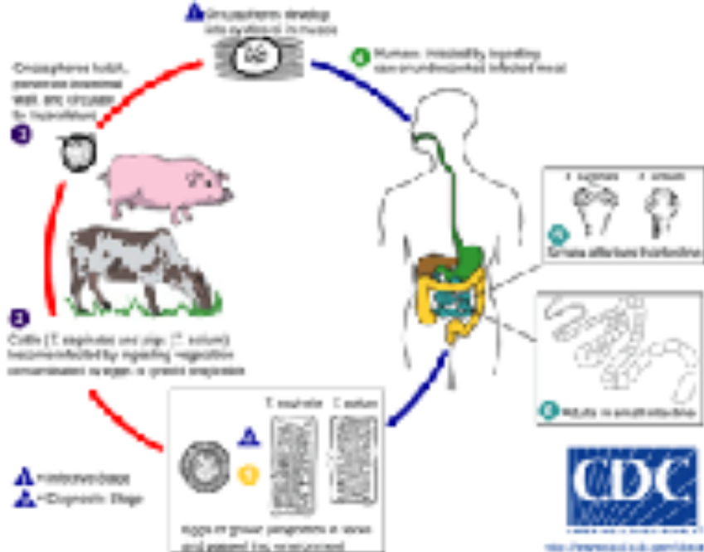
Platyhelminthes aren’t all nasty tapeworms! Some are quite amazing and strangely beautiful. Check out this video in the Shape of Life series. http://shapeoflife.org/video/flatworms-first-hunter
- A flatworm may have been the first animal to do what?
A flatworm may have been the first animal to move with the intent of hunting.
- What type of system was it the first to have?
Central nervous system
- What types of organs were flatworms the first to have?
Head with eyes and brain
- What is the benefit of having a pair of sense organs?
To sense its prey.
- How does the planarian feed?
triangulation
- What was evolutionarily novel about flatworm reproduction?
Development of internal fertilization system

- Describe the strange phenomenon of “penis fencing” in flatworms. What are the consequences for the loser?
Penis fencing in flatworms is when two jabs their penis toward each other about the midsection and the one that is successful releases sperms all over the body, hence the loser becoming the mother and sacrifices all the valuable resources.

Annelida
Annelids are distinguished by their segmented body form. They are coelomates that range in length from 1mm to over 3m in the giant Australian earthworm! While we are most familiar with earthworms, the diversity of annelids is phenomenal. Watch this next video in the Shape of Life series to discover the world of annelids. http://shapeoflife.org/video/annelids-powerful-and-capable-worms
- How many species have been discovered so far?
More than 15,000 species of Annelida

- Describe the ecological role of the Diopatra worms.
The ecological role of Diapatra worms is to generate a stable habitant for other organisms as well as stabilizing mud.
- How does the scale worm “make its living”?
They make their living by living on the underside of the scrounges and sea stars for food.
- Why don’t we feel the bite of a leech?
Leech injects an anesthetic into the body of an organism before biting, thus the reason as to why we don’t feel their bites.
- How long can earthworms live?
Up to seven years.

Mollusca
Molluscs include chitons, snails and slugs (gastropods), oysters, scallops, and clams (bivalves), and squid and octopi (cephalopods). After arthropods, molluscs are the most diverse phylum of animals, comprised of more than 93,000 described species. Although most are marine, there are about 8,000 freshwater species and about 23,000 species of terrestrial snails and slugs.
All molluscs are soft bodied coelomates, with some creating a protective shell of chitin and calcium carbonate.
Check out this next video in the Shape of Life series – Molluscs: The Survival Game http://shapeoflife.org/video/molluscs-survival-game
- What structure do molluscs use to feed?
Use radula to feed
- What structure supports the shell of most molluscs?
Mantle
- What structure do molluscs use for locomotion?
foot
- How does an abalone escape Pycnopodia – the many-armed sea star?
Abalone escapes pycnopodia by running away, turning and forcefully propelling itself from getting harmed.
- Explain the adaptations of the Nautilus that allow it to be a buoyant free-swimming organism relative to its sessile bottom dwelling ancestors.
The adaptations of the Nautilus allow it to be buoyant free-swimming organism in relation to its sessile bottom dwelling ancestors. This is when the water enters its body before being pushed out of a funnel that can direct the Nautilus.
- What is the trade-off in squid life history?
This is squid that only has small section of its old shell left before its lost it so as to become a fast swimmer.
- How have squid “amplified” the locomotive system of the nautilus?
The squid is amplified locomotive system of the nautilus by having a mantle wall that is strong and is simply advancement of system of the nautilus.
- What key adaptations do octopi have?
Camouflaging.

Echinoderms
DNA evidence suggests that Echinoderms such as sea stars, sea urchins, and sand dollars – are more closely related to chordates (vertebrates) than arthropods, despite looking less "animal-like", partly due to their semi-radial symmetry. Most echinoderms are slow moving or sessile. They have a thin epidermis that covers a calciferous endoskeleton of plates. Most are covered in small spines. They also have a unique water vascular system of hydraulic canals branching into tube feet that are used for feeding and locomotion. Males and females release gametes into the water during reproduction.
Use section 33.5 in your book to answer the following questions. (Section 33.5 was sent to you via separate attachment.)
- Sea stars can withstand incredible wave action in the intertidal zone. How are sea stars able to cling to substrates?
Sea stars are able to cling to substance with both chemical and muscular actions which allows them to attach and detach with tubed feet.

- Why might echinoderms make a more appropriate study species for making inferences about humans than other commonly studied species such as Drosophila fruit flies? (Hint: Think phylogenetics)
This is because humans have thought epidermis and diverged from bilaterally symmetrical ancestors like the echinoderms.

ARTHOPODS
A vast percentage of all biodiversity on earth, and the majority of animal diversity is comprised of arthropods. Some estimates suggest there may be 100,000,000,000,000,000,000 species (a billion billion), of which only 1 million have been discovered and described by science.
The external appendages of arthropods have become highly modified for specialized functions. They are segmented and come in pairs, for example antennae of insects or pincers of lobsters. Their bodies are covered by a cuticle, a hard exoskeleton comprised of chitin and proteins. The exoskeleton protects arthropods from predators and desiccation, and provides points of attachment for musculature.
Arthropods have an open circulatory system that circulates a blood-like fluid called hemolymph throughout the body. Hemolymph is pumped by the heart into short arteries and then into sinuses surrounding the organs and tissues called the hemocoel, which is not part of the coelom (the internal body cavity). Although arthropods are coelomates, in most species, the hemocoel replaces the coelom during development. Specialized gas exchange organs exist is arthropods, from gills in aquatic species such as lobsters and crayfish to spiracles in terrestrial species such as grasshoppers.

Marine Arthropods
We will break the massive diversity of arthropods into two major groups based on habitat – those that live in marine environments and those of terrestrial environments. Here is the Shape of Life segment on Marine Arthropods: http://shapeoflife.org/video/marine-arthropods-successful-design
- What is one of the key adaptations (“secrets of their success”) of arthropods?
One of the major adaptations of arthropods is the jointed legs which acts as shock absorbers and provides stability so as to function like an all-terrain vehicle.
- What is the evolutionary benefit of being segmented?
Allows them to adapt into almost any new opportunity. The segmented legs allow them to better adjust to new obstacles or terrain.
- What adaptation greatly helped them “dominate the sea”?
skeleton
- How do arthropods grow – what is this process called? What is the risk of this form of growth?
The arthropods grow a process called molting. This risk is that they are very vulnerable for the first two days after they molt.
- What types of extreme environments do marine arthropods live?
Ocean trenches and arctic ice by hydrothermal vents.
- Why may horseshoe crabs been the first marine animals to leave the sea?
This is because they seek their mates in the water but they go to the end of the ocean where they lay eggs on the land.

Terrestrial Arthopods
Next is the section on Terrestrial Arthropods: http://shapeoflife.org/video/terrestrial-arthropods-conquerors
- What modern species may be most similar to the first land animals?
Pill bugs
- What is an advantage of living on land?
There is more oxygen in air than in water.
- What does the scorpion have instead of gills?
Book lungs
- How does the millipede oxygenate its body?
Through trachea tubes that run along underside of its body which is derived from its exoskeleton.
- What was easier to digest than living plants for early terrestrial arthropods? What is this general group of arthropods called?
For early terrestrial arthropods, the dead matter of the deceased arthropods and plants called detritus was easier to digest than the living plants. This group of arthropods were known as detritivores.
- A newt, a vertebrate amphibian, can be prey for what arthropod?
Dragonfly larvae
- Through what process does a larvae become an adult?
Metamorphosis process
- What were arthropods the first terrestrial animals to do?
They were the first animals to develop wings to fly.
- What proportion of the world’s animals are flying insects?
Three-fourths of the entire animal population
- Spiders originally hunted on the ground. What selected for the evolution of webs?
The treat of predation of the flying insects was used for evolution of webs.
- What 2 vital roles do arthropods play in terrestrial ecosystems?
- Being pollinators
- Recycler of nature by playing some role in decomposition.
THE THREE TEXTBOOK PICTURES
